**Ctrl+Alt+Defeat**

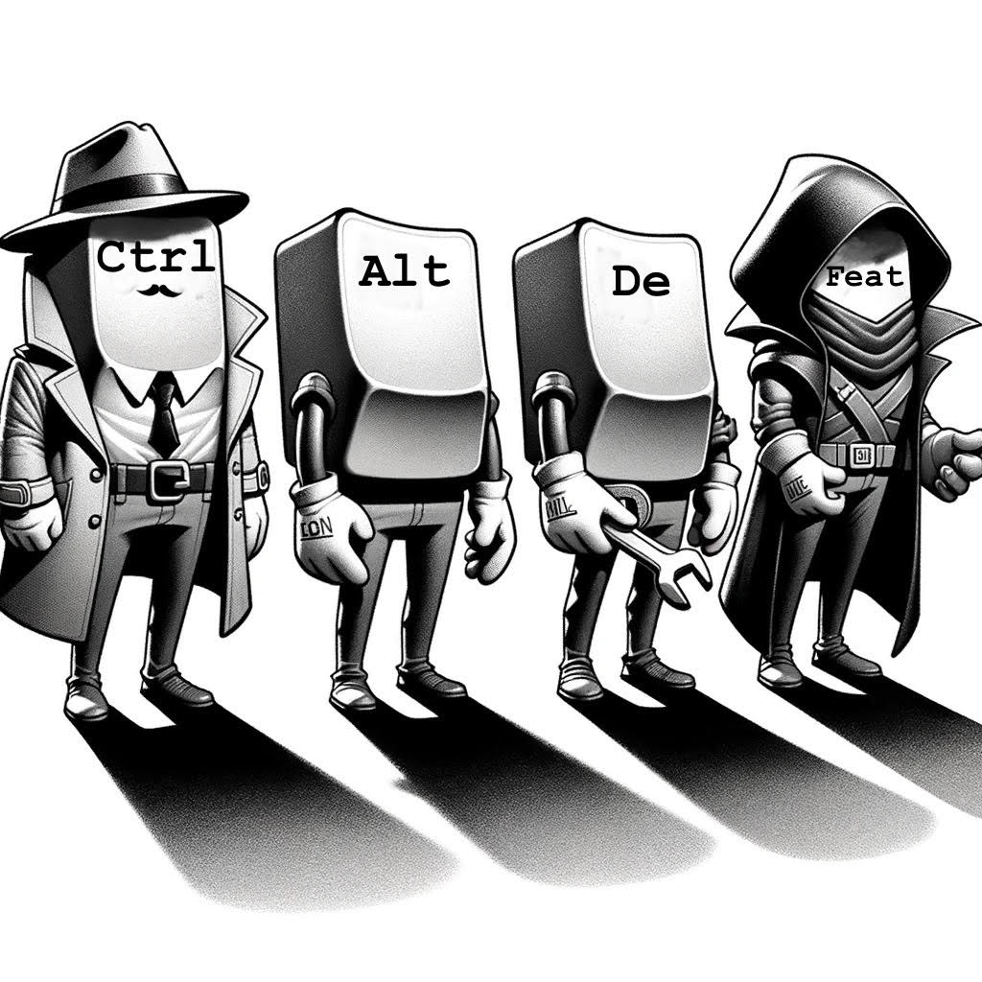

Malicious Android APK Injection

(Social Engineering Attack)

**Fullstack Academy**

Brookly, New York

Cybersecurity Bootcamp

**Analysis of a Social Engineering Attack: Compromise via Malicious Download**

A Capstone Project submitted by

Jesus Gonzalez, Marco Pigna, Mike Drake and RC Wright III

### 

### 

### 

### 

### 

### 

### 

### 

### **This Capstone Project was approved by:**

Class Instructor: Daniel Sefton

Class Mentor: Alex Harris

### 

### 

### 

### 

### 

Table of Contents

Chapter Page

1. Introduction 5

1. Executive Summary 5
2. Purpose of Project 6
3. Social Engineering and Effects 7-8

II. Technical Analysis 9

III. Incident Overview 1 10-11

IV. Incident Overview 2 12

V. Technical Review 13

1. Delivery Method SD Card (Retroid Pocket) 15-22
2. Virus Total Results 23
3. Delivery Method QR code or URL 24
4. Lenovo Tablet Results 25-27
5. Virtual Android Cellphones 28-29
6. Technical Defense on Android Devices Utilizing FOSS OS 30-31

VI. Impact Assessment 32-33

VII. Response and Mitigation 34-36

VIII. Lessons Learned 37

IX. Conclusion 38

X. References 39

Executive Summary

This report presents the culmination of Ctrl+Alt+Defeat’s comprehensive research and practical applications in Cybersecurity. Specifically, our project centers on investigating and addressing the looming specter of APK malicious attacks (side loading) targeting Android devices, a prevalent concern in the contemporary cybersecurity landscape that could be accomplished through Social Engineering infiltration attacks. The incident under scrutiny revolves around the targeted acquisition of an individual's Android device in a public setting. This orchestrated attack requires one or two individuals and can take anywhere between 30 seconds to 2 minutes. It begins with the phone being removed from the target's possession. The nearby hacker then plugs it into their terminal, downloads the APK, and returns the compromised device to the target. Or scans a simple QR code that immediately downloads the malicious APK and installs within a few seconds.

Purpose of Project

The primary objective of this Capstone project is to uncover vulnerabilities within commonly used devices, disclosing potential risks to user integrity and trust posed by Social Engineering attacks. Through this project, our aim is to provide valuable insight and awareness, ultimately allowing users to make informed decisions regarding their cybersecurity in today's tech-filled landscape.

With this Capstone Project, our mission extends beyond merely unraveling the tactics of APK malicious attacks. We wish to present effective countermeasures, educating ourselves with strategies to thwart these digital threats head-on. We acknowledge that social engineering ‘s a pivotal role in these assaults. We aim to bolster our defenses and empower individuals and organizations alike against these cloak-and-dagger maneuvers.

We have to navigate between theory and practice with determination. Through a blend of theoretical frameworks, hands-on experimentation, and data-driven analysis we have worked actionable insight on this topic. Our goal is to enlighten the public on practical recommendations and proven strategies that could help bolster personal cybersecurity resilience against an attack based on malicious APK files. This report showcases our dedication as new SOC Analyst’s to advancing cybersecurity. Through teamwork and a hands-on approach, we aim to create a safe digital world for all.

Social Engineering and Its Effects

Social Engineering embodies the art of exploiting human psychology to breach digital fortresses. It’s the manipulation of trust, curiosity or fear to coerce unsuspecting individuals into revealing secrets or unwillingly granting access to secure realms. Social engineering capitalizes on the vulnerabilities of human nature itself. It’s a game of deception where attackers orchestrate elaborate schemes, weaving narratives of deceit in both public or private settings, to dupe their targets into divulging confidential information or performing actions that compromise the very fabric of digital security. Where stakes are high and the consequences of a misstep could lead far beyond the confines of a digital domain. According to PT Security, in “Q3 2023, bad actors used various social engineering channels in successful attacks on individuals, with phishing websites being the most prevalent (54%), followed by email (27%), social media scams (19%), and instant messaging (16%)” (Positive Technologies). But there is another factor that the public should be aware of. Social Engineering Infiltration or a “collusive device compromise”.

This type of social engineering involves an orchestrated attack, involving both manipulation of the target and a coordinated effort to compromise their device for malicious purposes in any sort of public or private settings. It’s not as common, but an attack like that, to the right individual of a company/organization could have debilitating effects to their infrastructure. Atlas VPN conducted research within an observed period that showed that around “31% of all social engineering attacks were targeted at individuals, with the public administration sector following second at 18% of incidents. The numbers were based on the European Union Agency for Cybersecurity (ENISA)” (Edward, G). These types of attacks might not be as common as other Social Engineering attacks, but the amount of private and confidential data that could be breached is much more sensitive and could affect an individual or company in the long term.

Unfortunately, negligence, often coupled with collusion, remains one of the primary factors contributing to device compromise, potentially turning unwitting employees into unintentional insider threats within organizations. This collusive device compromise refers to situations where employees, either willingly or unwittingly, facilitate unauthorized access to sensitive information or systems

Detecting insider threats poses a large challenge to organizations, comparable to identifying external threats. According to a survey conducted by Enterprise IT World, an overwhelming majority (90%) of respondents in 2024 report that insider attacks are as difficult (53%) or more difficult (37%) to detect and prevent compared to external attacks. This marks a significant increase from 2019, suggesting a growing awareness of the subtlety and complexity of insider threats. Malicious insider threats have seen a significant rise from 60% to 74% since 2019, according to the same survey, solidifying their status as a definitive threat vector for stealing and misusing data.

The motives driving insider attacks can range from personal benefit and financial gain to revenge and sabotage. Without specific example studies, it’s challenging for organizations to fully comprehend the overall danger of these motives, making it crucial to contextualize them within real-world scenarios.

To combat the rising threat of insider attacks, organizations need to implement strategies that go beyond mere technical safeguards. While educating employees on the psychological elements of these attacks is essential, additional measures such as comprehensive security training, regular risks assessments, and more strict access controls are also of vital importance.

Technical Analysis

The AndroRAT malware is packaged as an APK in order to effectively, and efficiently target devices and systems running Android OS. The payload of AndroRAT includes malicious code written in Python and Java that allows for extended functionality of the malware once it compromises the target system. The behavior of this malware, like most Remote Access Trojan’s (RAT) is to give the attacker remote access to the system with functionalities similar to physically having the system. The attacker is able to execute remote commands from a Command and Control (C2) server, through a connection that is created once the malware is on the target system. In the case of AndroRAT the malware can be downloaded by the victim in various forms such as scanning a malicious QR code, or embedded into a phishing email. Once the link is downloaded the malware appears as a “Google Services” application. This is standard behavior of a RAT to appear as a harmless application or software, but as we know based on the AndroRAT malware the “Google Services” application is a facade for the malicious code to be executed once the application is opened by the victim.

When the AndroRAT source code is run from the host machine a shell interface is created to listen on a specific IP address over a specific port. Then once the file on the target system is inadvertently opened a connection is made back to this shell which gives the attacker remote access. Once this connection is established the attacker can leverage functionalities of the malware which include but are not limited to creating a shell on the target system, accessing log information, and accessing geographical data. Remote Access Trojans can be extremely difficult to identify on a system, and in the case of AndroRAT once the malware is executed it continues to run in the background until the attacker terminates the connection.

Incident Overview 1

**Incident Stage:** Simulated Attack on Android

**Title:** Target Social Engineering Attack Exploiting Android Devices Through APK File

**Date of Incident:** February 6th, 2024

**Location:** Bar/Cafe/Club

**Initial Search/Attack:** The attackers identify a potential target in a public setting, such as a bar, cafe or club, who is using an Android OS device. As social networks are readily available in today's age, it is easy for anyone to track down any top level executive or employee within an organization that could perhaps have access to crucial data of their day-to-day work.

**Approach to Target:** One of the attackers approaches the target, engaging them in conversation or creating a distraction to momentarily divert their attention away from their device. It could be casual conversation or flirting with the victim.

**Physical Acquisition:** During the distraction, the second attacker moves in and discreetly takes the target’s Android device from their possession without their notice. This approach could also be handled by attacker number one. If the attacker is deceptive enough they could come up with a story that they need to find their friend and require calling them real quick (as they have lost their cell phone), which would allow for them to unlock their phone, handing it out willingly without issue. This allows for ease of access of android internals.

**Transfer to Hacker:** At this point the hacker could easily be hiding in the bathroom where the exchange could happen. Once the device is in the hackers hands they could quickly transfer the malicious APK file either through a portable laptop.

**Connection to Hacker Terminal:** The hacker then connects the device to their terminal or computer using a USB cable or wirelessly, gaining direct access to the device's data and settings.

**APK Installation:** The hacker downloads and installs the malicious APK file which would run in the background without any initial alerts. The AndroRAT APK would connect their device to the hackers terminal allowing them to wireless canvas their device for any information such as SMS texts, Videos, Phone Call logs, Private Files, Audio Files, etc..

**Device Return:** The device would be returned by the first attacker after installing the APK file.

**Infiltration Complete:** The attack is complete, with the target being unaware that their device has been compromised and is now susceptible to unauthorized access or data theft.

**Summary:** Such an attack is possible through a high level of coordination and execution by the attackers, emphasizing the effectiveness of social engineering tactics combined with smooth physical theft and technical exploits of the Android device’s vulnerabilities. With such an attack they can now easily gain every megabyte of data the user has and compromise their personal and professional life.

Incident Overview 2

**Location:** Cafe/Restaurant

**Initial Search/Target:** The attackers identify a potential target in a public setting, such as a cafe, restaurant (QR Code Menu), who is using an Android device.

**Approach to Target:** One of the attackers approaches the target, engaging them in conversation or creating a distraction to momentarily divert their attention away from their device.

**QR Presentation:** During the interaction the attacker could present the target with a QR code, claiming the code would lead to special offers, discounts or even menu services. At this point the attacker could ask to see their phone so they could do it for them. All it takes is exactly 3 taps to approve the APK and install it.

**Malicious APK Download and Control:** Unknown to the target, the scanning of the QR code initiates the automatic download and runs passively in the background allowing a backdoor access to the device for the hacker.

**Device Return:** With the malicious APK installed which would take less than 10 seconds to process through, the attacker discreetly leaves the area, often during the same distraction initiated earlier.

**Exploit Complete:** Attack is complete, with the victim unaware that their device has been compromised by a hacker.

**Summary:** The scenario showcases how social engineering can have multiple angles, some extensive and others very simple. The approach urges some curiosity or interest from the target which can be manipulated to the hackers advantage. This allows the individual into unwittingly compromising their Android device by scanning what they believe to be a simple and harmless QR code.

Technical Review

Reverse shell on Android 11 - 13 devices

Building Malicious APK

* Through the use of AndroRat a payload was created as “androidservices.apk” this APK will be the item delivered to the targets device.
* The APK guises itself as a google framework service

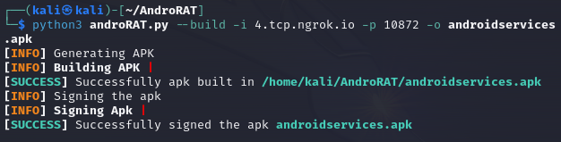

* Note the IP address is the Ngrok forwarding information

Starting Ngrok and AndroRAT



AndroRAT and Ngrok waiting for connection

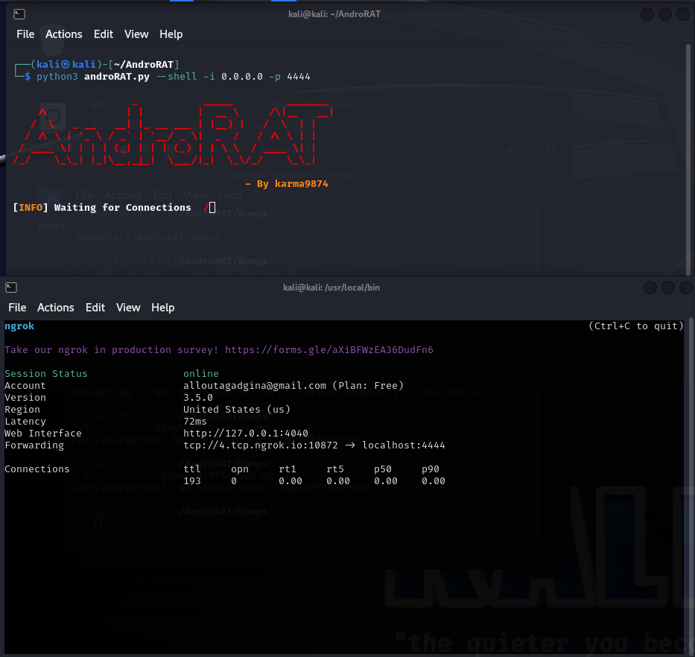

### 

### 

### 

### 

### 

### 

### 

### **Delivery Method SD Card**

**Retroid Pocket 3+**



Installing the malicious APK via SD card

* Android Version 11
* Android Security update: July 5, 2022
* Google Play system update: October 1, 2021
* Device is updated as far as it is allowed
* The Retroid Pocket 3+ is a popular handheld gaming device that is developed by GoRetroid a Chinese tech company to emulate retro video game systems. The devices’ focus on portability and power allowed it to gain immense popularity among American tech enthusiasts. Recently, the availability of this device has dramatically increased due the amount of third party sellers now offering this device on Amazon.

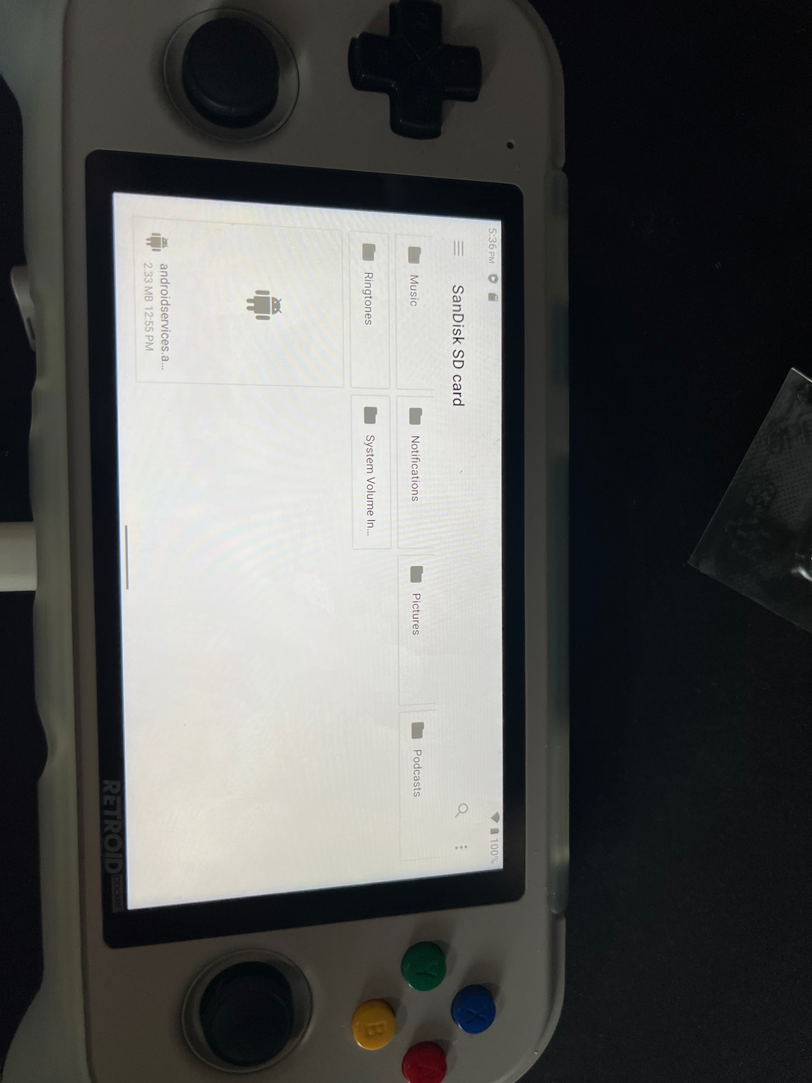

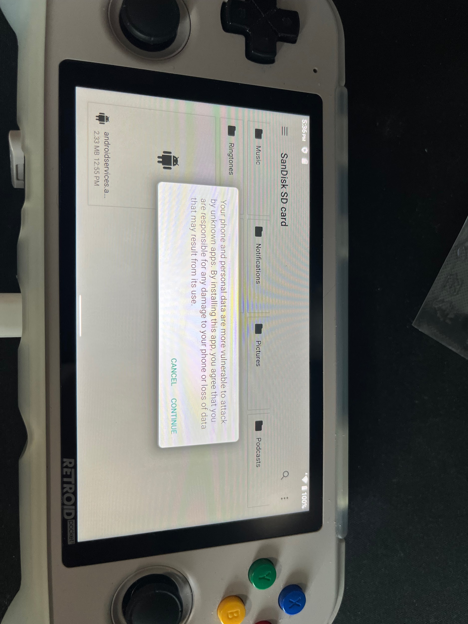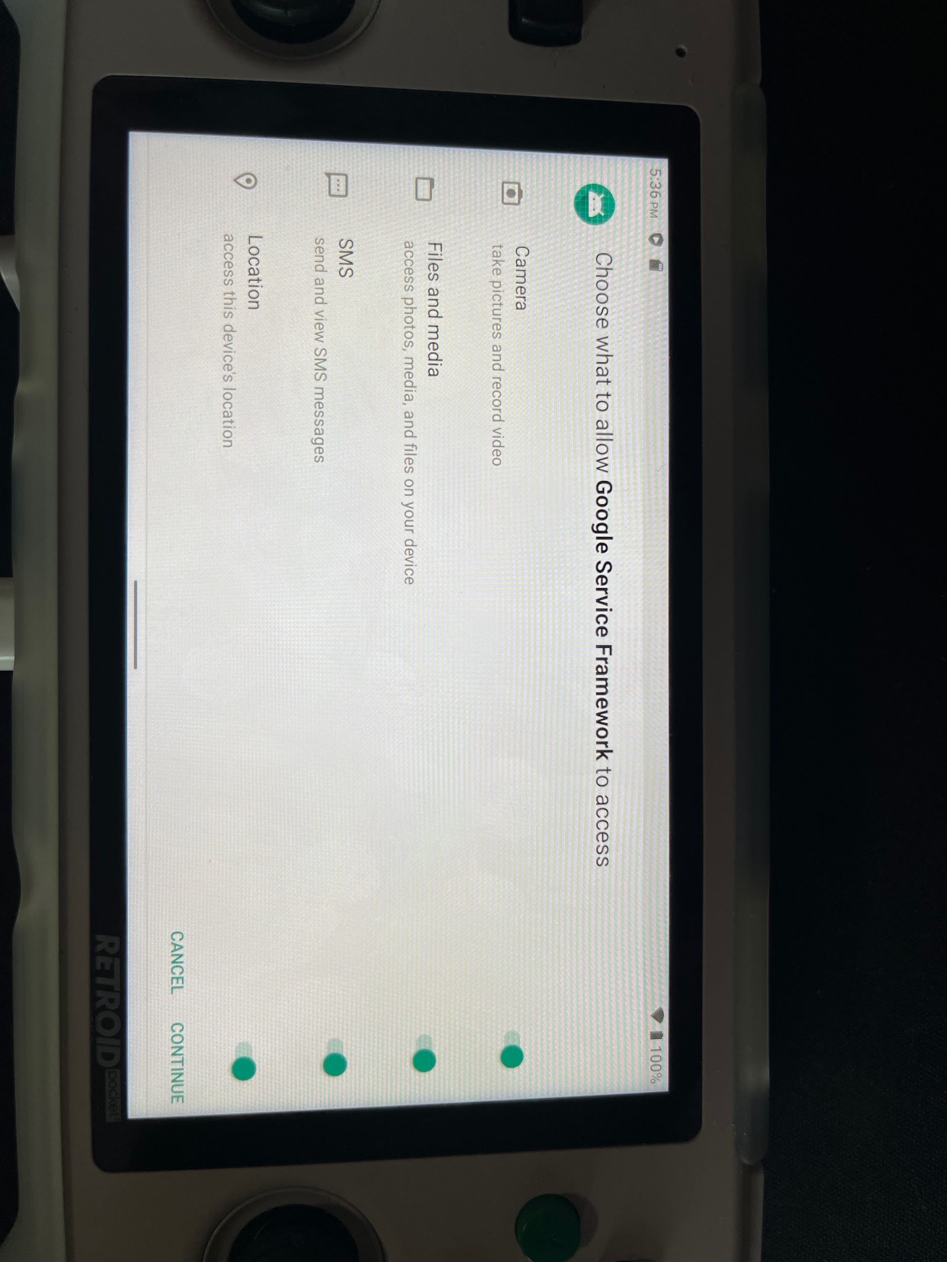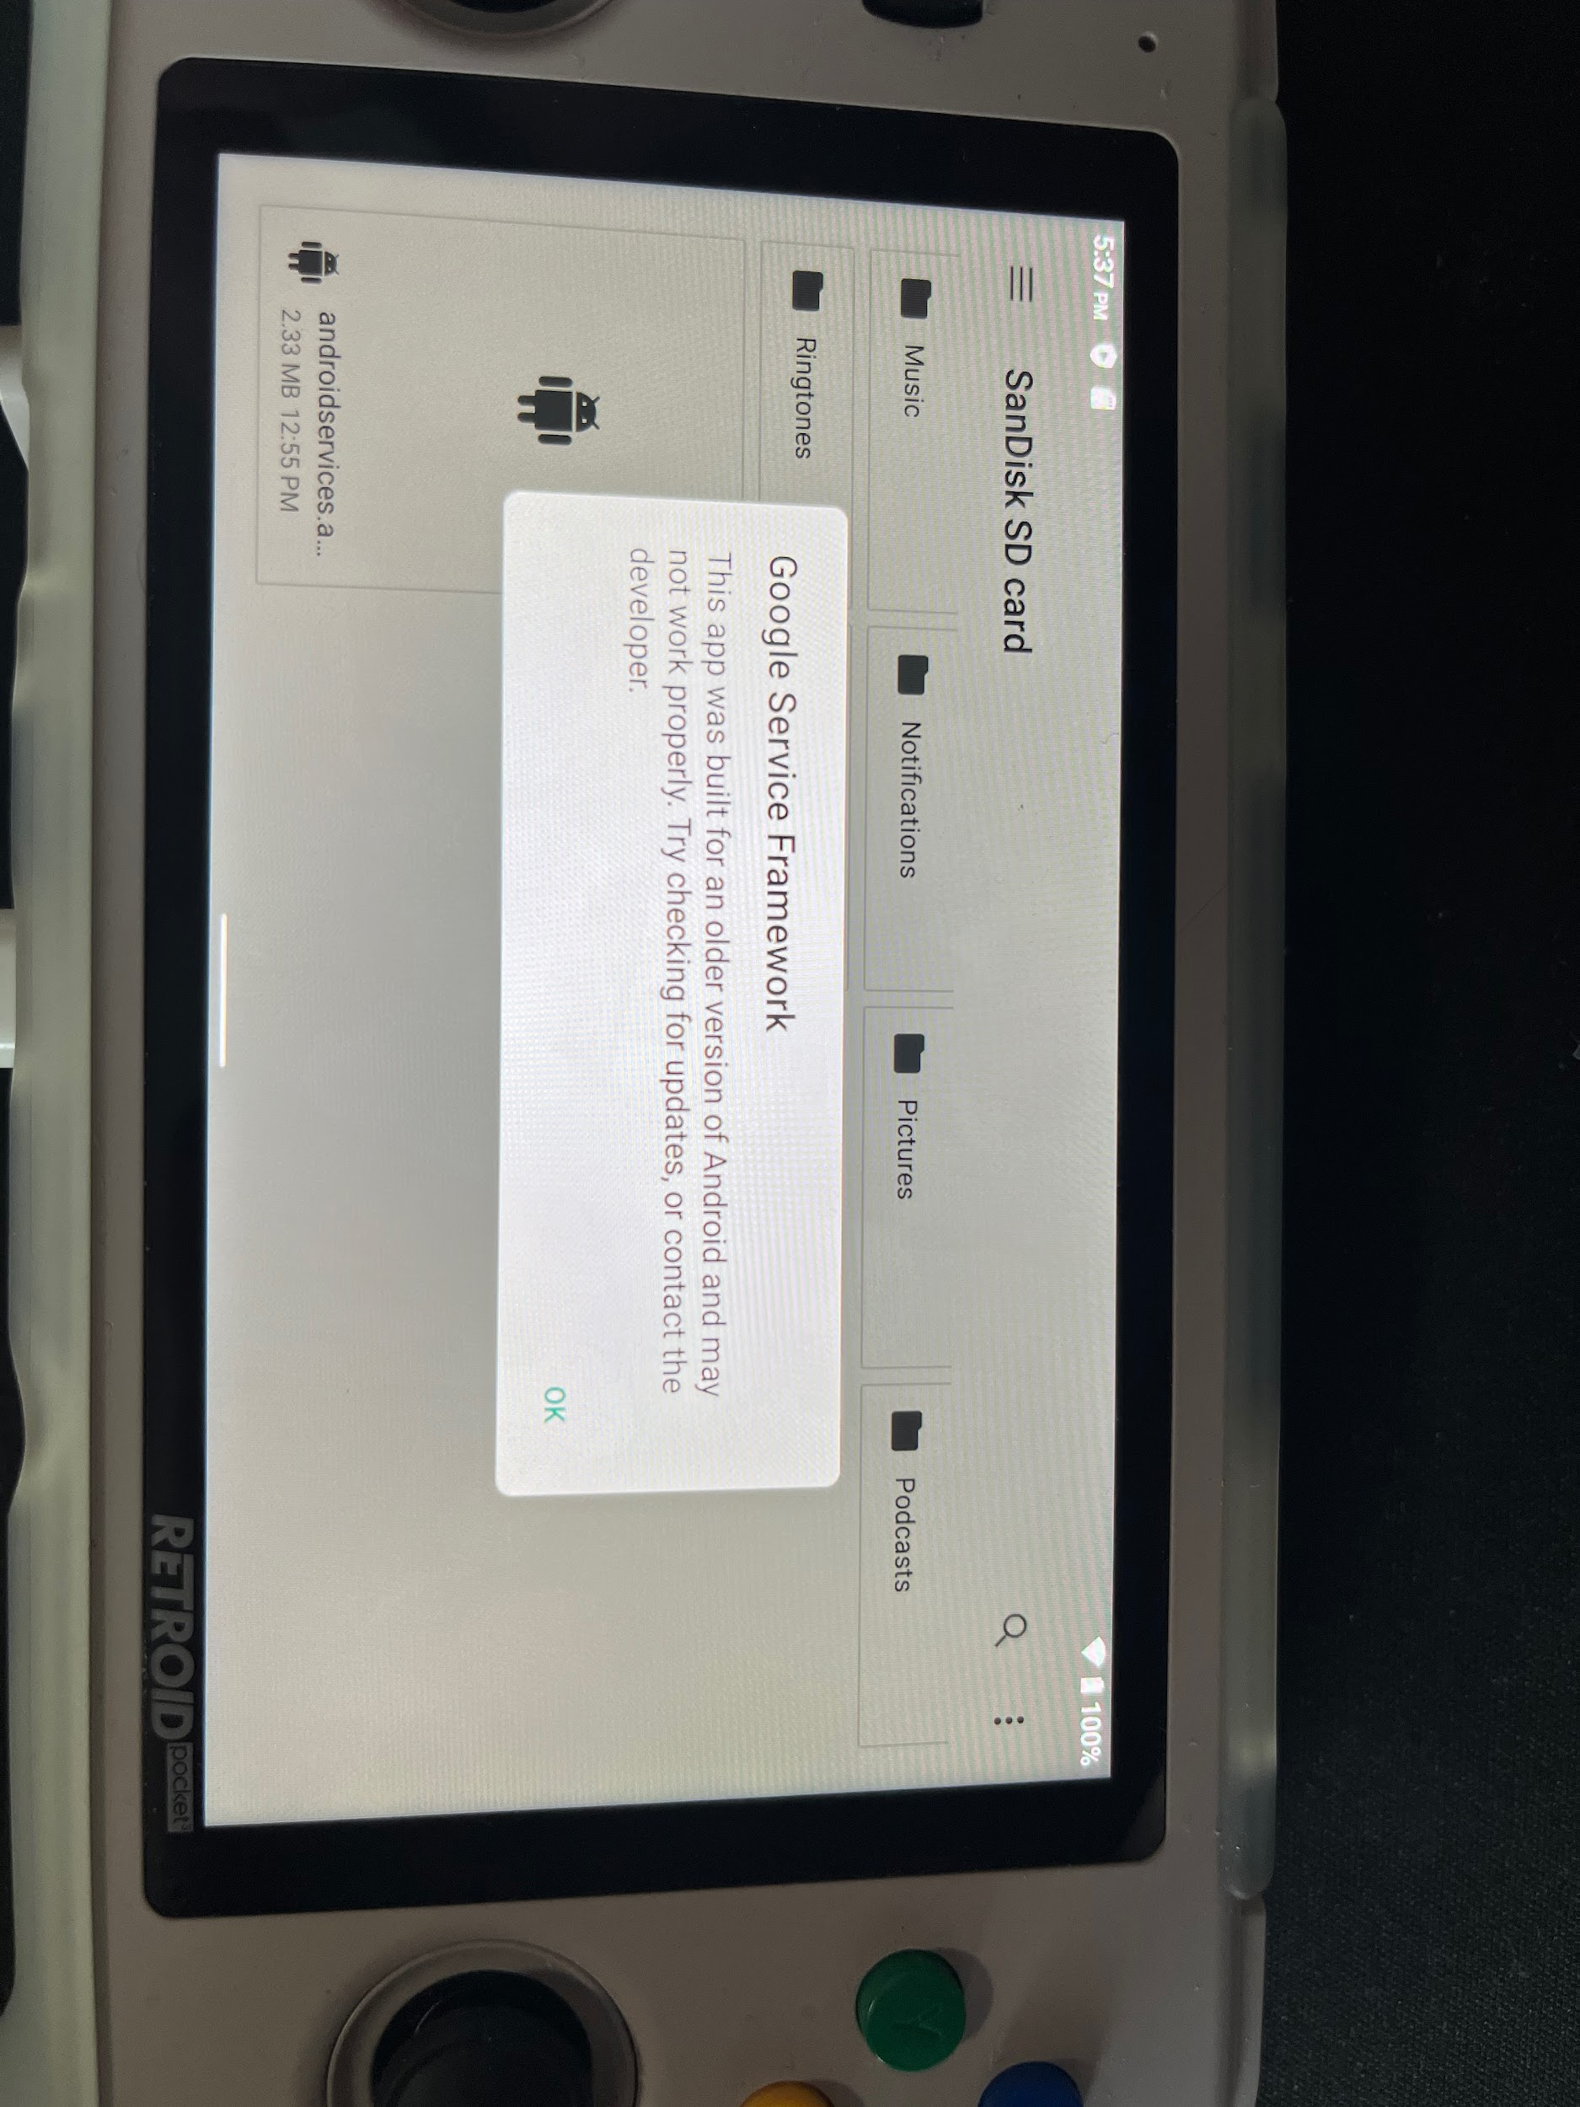

AndroRAT and Ngrok responding to installed APK on the Retroid Pocket 3+

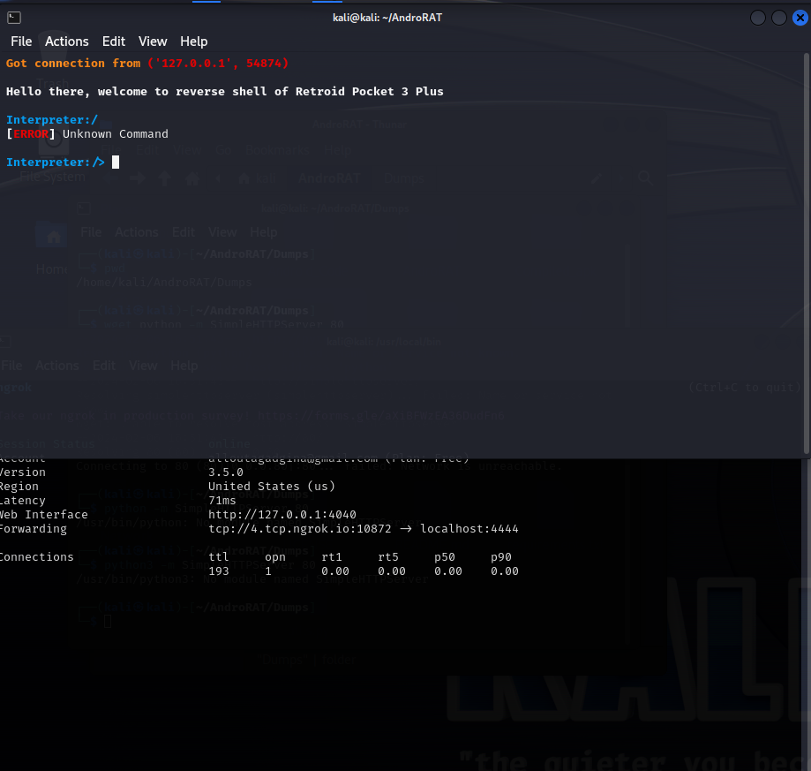

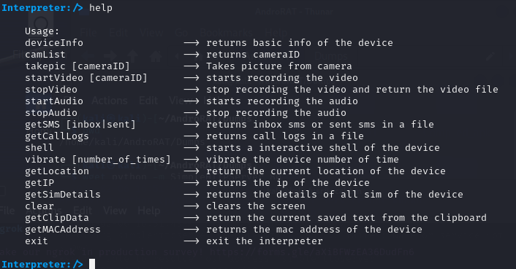

Device Info

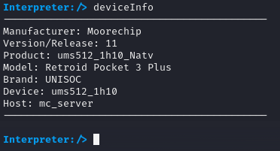

Mac Address



Shell

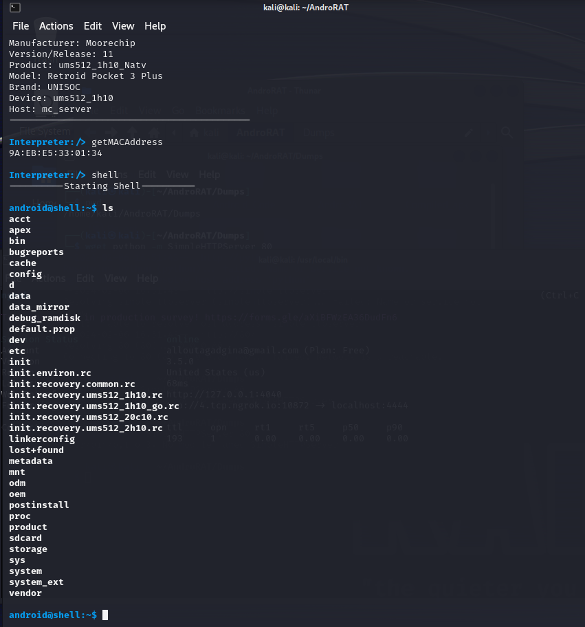

Creating a file

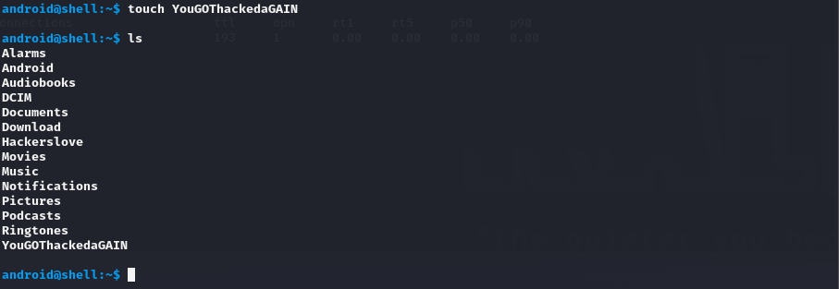

NetCat support

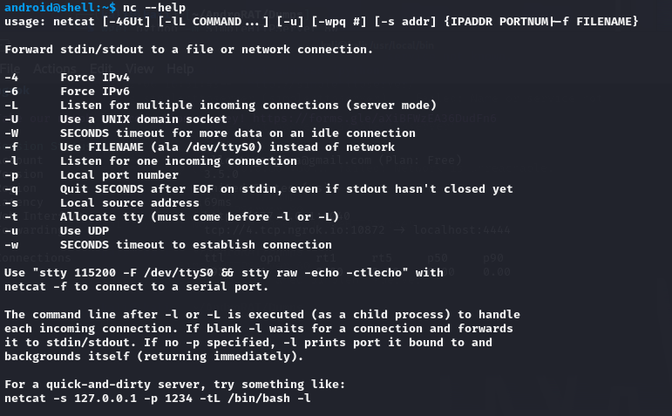

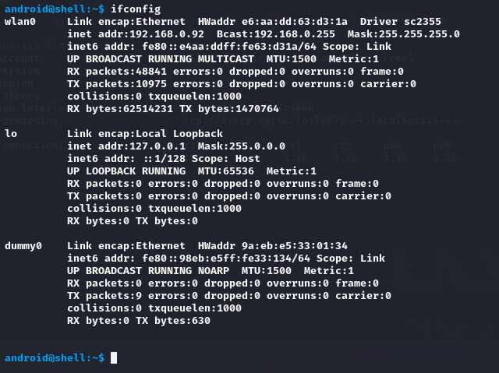

Placing and stealing files with get and put commands

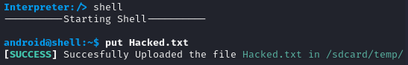

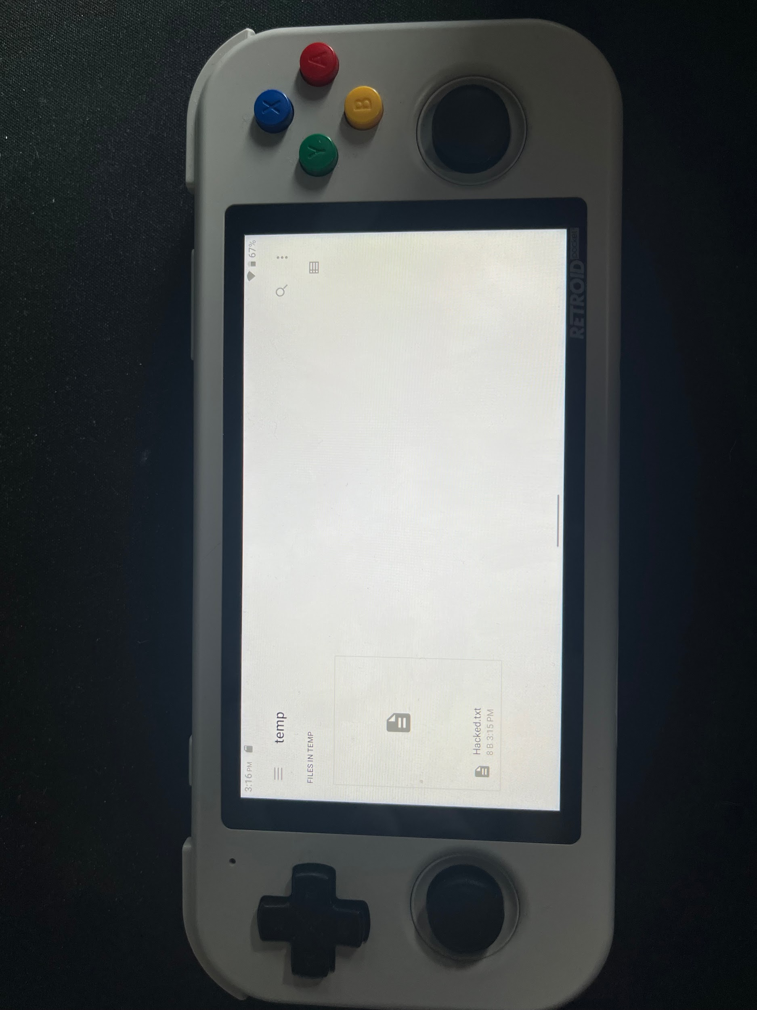



### 

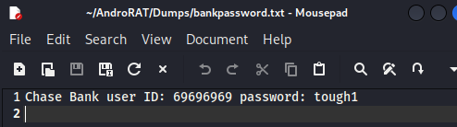

**Virus Total Results of the APK**

### 

### 

### 

### 

### 

### **Delivery Method QR code or URL**

Qr code or URL through File.IO one time use

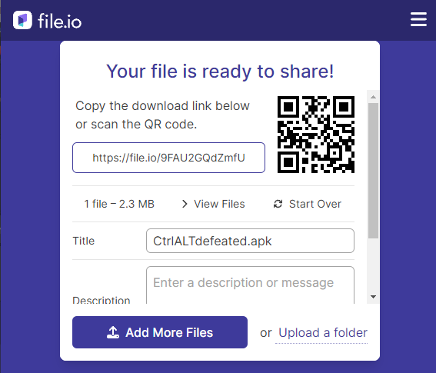

### 

### 

### 

### 

### 

### **Lenovo Tablet**



Android Verison: 12

* Android Security update: August 5, 2023
* Google Play system update: October 1, 2023

Method of delivery: URL

* Working
  + Vibrate phone
  + List cameras
  + System information
  + MAC address
  + Location
  + Dump call logs
  + Dump sms logs
  + Record Audio
  + Shell
    - Working
      * Netcat
      * PWD
      * Ifconfig
      * Get
        + Use truepath and steal a file
      * Put
        + Insert a file to the device
    - Not Working
      * ls permission denied
      * cd
* Not working
  + Take photo / video

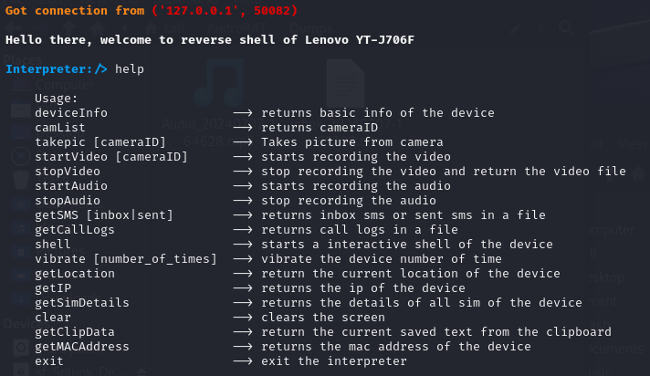

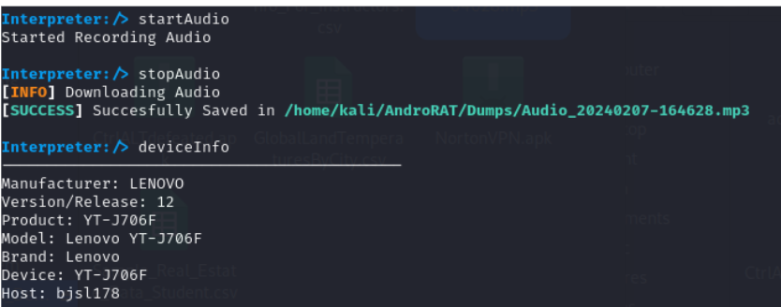

### 

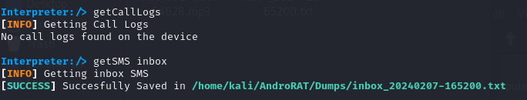

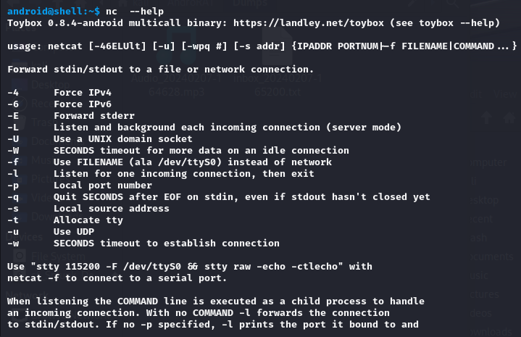

### 

### 

### 

### 

### 

### **Virtual Android Cellphones**

Android 12 and 13

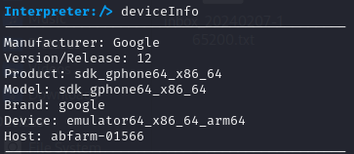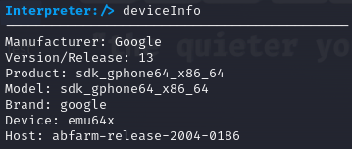

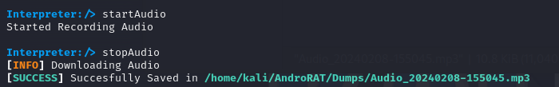



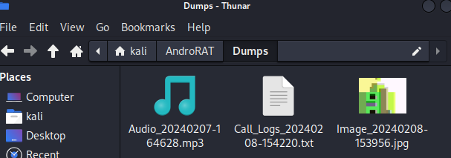



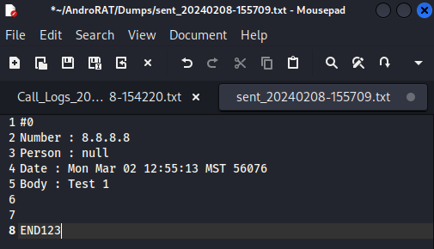

### 

**Technical Defense on Android Devices Utilizing Security-Centric FOSS OS**

Device: Pixel 6 Pro

Android Version: 12

GrapheneOS Version: Raven ​​2024020500

Attack Vector: Malicious QR code with an embedded AndroRAT APK

In a third attempt to breach an Android device utilizing AndroRAT, a device with an alternative FOSS OS (GrapheneOS) effectively neutralized the operation of AndroRAT on a Pixel 6 Pro device, leveraging its security-oriented design. The initial infiltration attempt by AndroRAT utilized a QR code, directing the device to download the malicious apk. This method highlights the adaptive tactics employed by cyber threat actors in attempting to bypass PED security measures. Upon scanning the QR code, the device proceeded to download the AndroRAT apk, marking the initial phase of what could have been a successful compromise of the device.

GrapheneOS is engineered as a security-focused operating system, optimized for Pixel devices to include the Pixel 6 Pro. It diverges from standard Android OS by eliminating Google Services Framework and implementing advanced security features. These features encompass stringent sandboxing, precise permissions management, and enhanced memory safety protocols. GrapheneOS thereby fortifies the device against unauthorized access and software exploits, establishing a hardened environment resistant to malicious applications and cyber attacks.

Upon attempting to activate, AndroRAT's functionality was impeded by GrapheneOS due to the absence of the Google Services Framework, a critical dependency for many Android applications, including various forms of malware. The exclusion of Google Services Framework is a deliberate security measure within GrapheneOS, significantly minimizing potential attack surface and vectors that malicious actors could exploit. As a result, despite AndroRAT's successful download onto the device, its inability to interface with the necessary Google infrastructure prevented any further execution. This example underscores the effectiveness of a security-first operating system architecture, showcasing how prioritizing user safety at the system level can neutralize threats before they materialize into active security breaches.

### 

### 

### 

### 

### 

### 

### 

### 

### 

### 

### 

### 

### 

### Impact Assessment

The AndroRAT malware attack that we have carried out in our project demonstrates, in a controlled, small-scale environment the damage that can be done when the attack is successfully completed. What we have illustrated above is the effective use of our attack vector to gain remote access onto a system. In the case of our project we were able to gain remote access and successfully carry out various commands on two systems utilizing Android OS. One system was a Retroid Pocket 3+ and the other successfully compromised system was a Lenovo Tablet. Our attack was able to exfiltrate data, remotely control the victim device, obtain geographical coordinates, and access sensitive data. The impact of this attack in a controlled environment remains minimal as we have put in the proper controls to avoid any serious impact. However, in the wild, an attack similar to ours carried out by a malicious actor could be extremely impactful and cause serious damage for not only individuals, but also for companies, and organizations.

In our assessment the data that we obtained included MAC addresses, call logs, sms logs, system information, IP addresses, and geographical locations. All of this information is not only sensitive in itself, but information such as call and sms logs can contain further sensitive information that a malicious actor can utilize to carry out additional attacks. The ability to pinpoint a victim's geographical location is concerning not only due to the invasion of privacy but also because it opens up avenues for physical tracking and surveillance, posing a direct threat to personal safety. Moreover, the accessibility of sensitive data such as MAC addresses and IP information can facilitate network infiltration and targeted cyber attacks against individuals or organizational infrastructures.

Overall, the implications from gathering victim data create additional privacy and safety concerns. The potential for exploitation extends beyond the initial unauthorized access and remote control, enabling malicious actors to construct elaborate schemes, including identity theft, financial fraud, and sophisticated social engineering attacks that exploit personal and organizational vulnerabilities. Insights gained from our project’s controlled demonstration of the AndroRAT attack reveal the necessity for continuous user training, and proper technical measures for preventing such attacks. The AndroRAT malware that we used was only supposed to have capabilities in Android OS versions 4.1 - 9.0. Notably, our success in extending the malware's effectiveness to Android OS versions 11 and 12—beyond its intended capability—serves as a reminder of the persistent challenge in maintaining up-to-date security protocols.

### 

### 

### 

### 

### 

### 

### 

### 

### 

### 

Response and Mitigation

**Immediate Response Actions:** Upon detection of the AndroRAT malware infiltration on the Retroid Pocket 3+ or the Lenovo Tablet utilized in this demonstration, immediate response actions would be crucial to containing and mitigating the attack. In the instance of a malware infiltration such as AndroRAT, immediate action should include segregating infected systems from the network to halt malware propagation and prevent data leakage. This step is important as to contain the malware within compromised devices, thereby protecting the wider network infrastructure. Following isolation, an analysis is necessary to locate and eradicate the malicious APK files on the devices. Utilizing dedicated mobile security software to detect and remove AndroRAT components is essential to eliminate any remnants of the malware that could lead to subsequent vulnerabilities. In parallel, it's imperative to identify and rectify the security weaknesses that permitted the malware's entry. This involves promptly applying patches to these vulnerabilities, reinstating the security of the impacted systems.

**Longer-Term Response Actions:** For future prevention of breaches similar to the AndroRAT attack, it is important to conduct a thorough review and update of existing security policies and protocols. It is necessary to refine security protocols, incorporating stricter access controls, and regular updates for software and firmware.

In addition, a security awareness program should be established to educate end users on the dangers of downloading software from unverified sources, identifying phishing schemes, and the critical importance of consistent software updates. The end goal being to develop a security-conscious culture where users are equipped to act as the primary defense against cyber threats.

Regular security audits of both users and devices and the creation of a proactive incident response plan are pivotal in ensuring compliance with organizational policies. This plan should detail the steps for incident detection, analysis, containment, elimination, and system recovery, enabling a rapid response and restoration in the event of a cyber incident. These plans are not only in place to counter specific threats like AndroRAT but also to strengthen the organization's overall defense against a broad range of cyber threats, safeguarding sensitive data and maintaining operational integrity.

**Addressing Legacy Malware Threats:** The effectiveness of AndroRAT against our test devices, despite it targeting older Android OS versions, highlights the ongoing risk posed by legacy malware. This incident highlights the need for a comprehensive reassessment of mobile device security protocols, while recognizing the evolving threat landscape. In addition to the end user being the first line of defense against such attacks, embracing security-centric FOSS operating systems, coupled with a commitment to applying the latest software updates and patches, forms a critical part of this strategy.

Adapting to the persistent nature of such threats necessitates a broad reevaluation of mobile security defensive approaches. By integrating advanced, security-first operating systems and ensuring all software is up to date, the likelihood of attacker success during similar attacks can be significantly minimized, reinforcing the organization's resilience against both current and future cyber threats.

A pivotal long-term strategy could include adopting security-centric FOSS operating systems for vulnerable mobile devices (on devices in which they are compatible). These operating systems provide advanced security features, such as minimized attack surfaces, enhanced sandboxing, and improved permissions management (as compared to a commercial OS), effectively reducing the risk of malware infiltrations.

As shown by our testing of the Pixel 6 Pro, in response to the AndroRAT infiltration, prioritizing the use of security-focused FOSS operating systems for mobile devices is recommended as part of an enhanced cybersecurity strategy. This approach acknowledges that conventional security practices (and traditional PED OS) may not be sufficient against sophisticated malware threats. Operating systems like GrapheneOS and CalyxOS are built to prioritize privacy and security, offering strong alternatives by reducing the attack surface and excluding commonly exploited services.

Transitioning to these FOSS operating systems can drastically decrease the chances of malware breaches. These platforms allow for tighter control over application permissions and limit access to essential data and system functions, reducing the impact of any malicious applications. Their open-source nature also encourages continuous community-led security evaluations of the source code, ensuring quick vulnerability identification and resolution.

### 

### 

### 

### 

### 

### 

### 

### 

### 

### Lessons Learned

### The key takeaways from our incident indicate the importance of continuous end user training, and awareness of the cyber threats that are readily available in the technological landscape in which we live. Malwares such as AndroRAT requires some type of user intervention to get the malicious APK onto the victim device. Whether that be through downloading a malicious link, or scanning a malicious QR code. At the end of the day this malware and its capabilities can in most cases only be enacted because the end user inadvertently allowed it. That is why user training and awareness is of the utmost importance. If end users were made more aware of the vulnerabilities and threats that exist then maybe they would think twice before scanning a random QR code or downloading a link that may seem suspicious. Nonetheless, as these threats do continue to develop and find new attack vectors there are additional technical safeguards that are put in place to try to prevent these attacks from happening. However, these should not be the sole means of protection that an end user relies on to keep their systems and personal information safe and secure. Additionally, our ability to bypass security controls in newer Android versions than initially anticipated points to a critical lesson about overestimating the effectiveness of existing security measures and the constant need for security reevaluation and enhancement. These insights collectively stress the importance of a proactive, comprehensive approach to cybersecurity, integrating technical controls, user education, and ongoing vigilance to safeguard against evolving digital threats.

### 

### 

### 

Conclusion

In essence, by acknowledging the growing importance of public perception regarding insider attacks, organizations recognize the need to prioritize cybersecurity as a fundamental aspect of their risk management and business strategy. This involves investing in robust security measures, fostering a culture of security awareness and accountability, and demonstrating a commitment to protecting sensitive information from insider threats.

Social engineering infiltration can help insider threats to evolve in sophistication and frequency, businesses must recognize the importance of proactive cybersecurity measures. This includes not only investing in technological solutions but also a collaborative approach to threat detection and prevention across all levels of the organization.

In addition, the impact of insider threats extends beyond immediate financial losses and operational sabotage. It can diminish an organization's reputation, leading to long-term repercussions such as a loss of business future opportunities and overall legal liabilities. Addressing insider threats will require a deep approach that encompasses not only technical defenses but also a company's culture, policies and practices.

By promoting transparency, accountability, and a strong ethical framework, organizations can help encourage their employees to act as allies and a unified front to fight against insider threats. This would require not only educating but providing resources for reporting suspicious behavior and increasing trust collaboration among workers.

In doing so, organizations can not only protect their sensitive assets but also strengthen their resilience in evolving cybersecurity challenges. And they can safeguard their reputation, build trust with stakeholders, and ensure the long-term sustainability of the business operations in an increasingly digital and technology driven world.

### 

### References

Enterpriseitworld. “From 2019 to 2024, the Number of Insider Attacks Increased from 66%...” *Enterprise IT World*, 25 Jan. 2024, [link.](https://www.enterpriseitworld.com/from-2019-to-2024-the-number-of-insider-attacks-increased-from-66-of-organizations-to-76/) Accessed 8 Feb. 2024.

G, Edward. "Individuals Targeted in Social Engineering Attacks in 2023." *Atlas VPN - Freemium VPN Service For Security Online*, 6 Nov. 2023, [link](http://atlasvpn.com/blog/targeted-individuals-most-likely-victims-of-social-engineering-attacks-in-2023#:~:text=During%20the%20observed%20period%2C%20around,Landscape%20report%2C%20October%202023%20edition). Accessed 7 Feb. 2024.

Positive Technologies. "Cybersecurity Threatscape: Q3 2023." *Ptsecurity.com*, 13 Nov. 2023, [link](http://www.ptsecurity.com/ww-en/analytics/cybersecurity-threatscape-2023-q3/#:~:text=In%20Q3%202023%2C%20bad%20actors,instant%20messaging%20hoaxes%20(16%25)). Accessed 7 Feb. 2024.

Raza, Muhammad. "Social Engineering Attacks: The 4 Stage Lifecycle & Common Techniques." *Splunk-Blogs*, 13 Feb. 2023, [link](http://www.splunk.com/en_us/blog/learn/social-engineering-attacks.html#:~:text=98%25%20of%20cyberattacks%20rely%20on,access%20to%20sensitive%20business%20information). Accessed 7 Feb. 2024.